**ASSOCIATION RULE LEARNING**

**(ECLAT)**

[Simplified Apriori Model]

It also talks about “people who bought this also bought this”.

Apriori → better

if only simple and quickly required then apply Eclat.

Different rules have different strengths. In apriori based on the lifts we judge the strengths of different rules. Whereas, here we are going to be talking about sets.

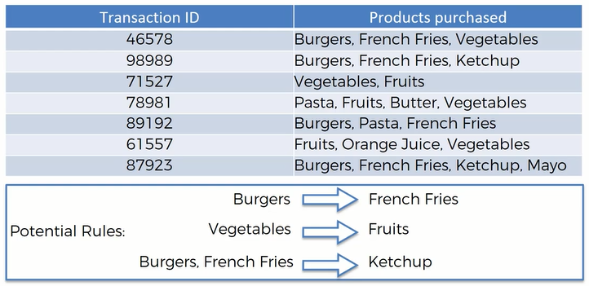

Here, we have got market basket as optimization and some potential rules. And the Eclat Model is responsible for actually going through all of these combinations and telling us what we should focus on.

In Eclat model we only have support.

